Maintenance Manager
Release Notes v4.1.0.0

Contents
1 Document Control 3
1.1 Author 3
1.2 Document Summary 3
1.3 Document History 3
1.4 Reference documents 3
1.5 Distribution 3
1.6 Quality Assurance 3
2 Introduction 4
3 New Functionality 5
3.1 Raise Defect with Multiple Repairs via Locator 5
Additional Defect Details 5
New Repairs Step 6
3.2 Additional Cost Code fields for Budgeting 9
3.3 Accumulative discount banding 10
3.4 Contractor Security 11
Contract Admin Unit Security 11
Contractor User Security 11
New Product Option CONSECMODE 12
Contract Admin Unit Security 12
Contractor User Security 13
4 Log No. Summary 14
4.1 Customer Raised Issues 14
4.2 Exor Raised Issues 18

- Document Control
  - Author
Exor Development

  - Document Summary
This document provides a list of all Logs fixed in this release and information about new functionality.

  - Document History

Document History
Revision | Date | By | Description
1.0 | 20-Oct-2009 | Rob May | Draft issued to customers

  - Reference documents
None

  - Distribution
Exor Customers, Partners and Staff

  - Quality Assurance
Document Details
File | Prepared By
0000.doc | Rob May
Document Name | Reviewed By
Maintenance Manager Release Notes v4.1.0.0 | Mike Huitson
Version | Approved for issue by
1.0 | Colin Stewart
Date of Issue | Support Manager
20-Oct-2009 | Graham Anns

- Introduction
This document describes the changes made to Maintenance Manager product at release v4.1.0.0 and is specifically targeted at end users.

After reading through this document, should you have any further training or consultancy requirements then please contact your exor account manager.

If you require further details on upgrading product components then please consult the relevant product Upgrade Guide.

- New Functionality
This Chapter describes the main areas of functionality that have been changed in this release.

NB. This section does NOT serve as a User Guide to Maintenance Manager functionality

  - Raise Defect with Multiple Repairs via Locator

Additional Defect Details

The following fields have been added to the “Defect Details” step:-

Inspectors Initials

Safety / Detailed Flag

Notifiable Organisation

Rechargeable Organisation

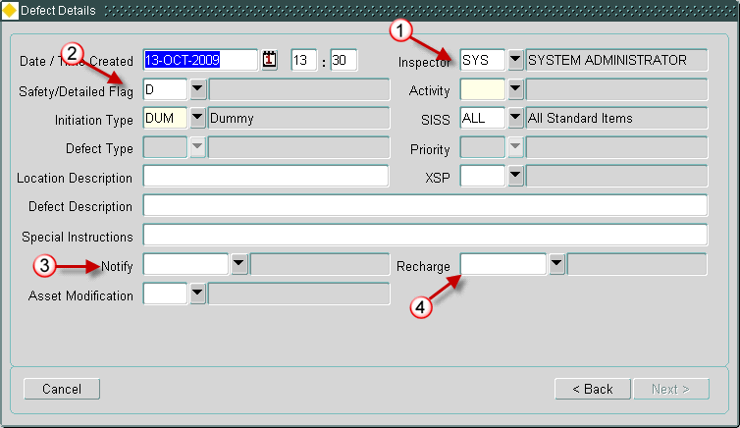

New Repairs Step

A new “Repair Details” step has been added to allow the user to enter details for one or more repairs for the defect(s).

This new step contains three tabs, one for each repair type.

Because the repair fields that a user can populate are not mandatory it is necessary to tick the “create repair” box on each tab to indicate that a repair of that type should be created, however if data is entered in one of these optional fields the tick box will be automatically populated.
In order to maintain the previous flow through the wizard as closely as possible the Permanent Repair will default to ticked.

The Permanent and Temporary Repair tabs allow the user to create BOQs to be associated with the Repair on that tab.

Where appropriate the BOQ blocks will be automatically populated using a treatment model when the user enters a Treatment.

As well as the BOQ block each tab contains the following fields:-

Permanent Repair
- Create Permanent Repair tick box
- Treatment
- Date Due (read only)
- Description

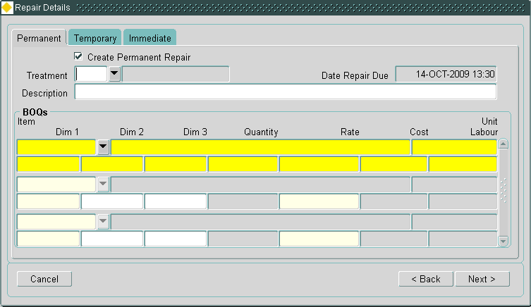

Temporary Repair
- Create Temporary Repair tick box
- Treatment
- Date Due (read only)
- Description

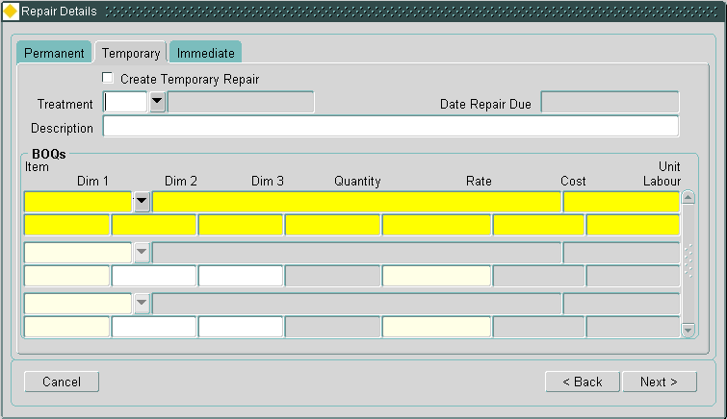

Immediate Repair
- Create Immediate Repair tick box
- Treatment
- Date Due (read only)
- Description
- Time Completed

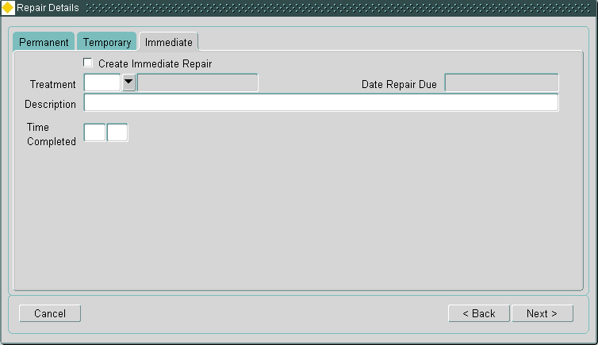

NB. In previous versions the Wizard presented the user with the opportunity to edit the newly created (but not yet committed) defects before exiting the wizard. This remains to be available when a single repair has been specified, where multiple repairs have been specified the user will need to exit the wizard and use the standard Inspections form (mai3808) to edit the Defect(s).

  - Additional Cost Code fields for Budgeting
Three additional cost codes can now be associated with a budget.

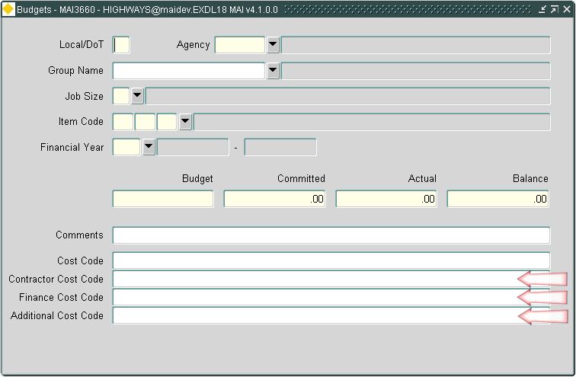

  - Accumulative discount banding
This enhancement allows the option to have Discount Group calculations carried out accumulatively by discount band.

This option can be enabled by putting a tick in the new “Accumulative Discount” checkbox on the discount Bands form.

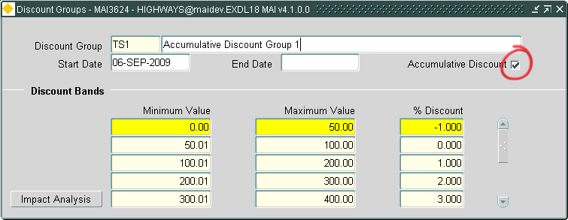

Using the banding shown in the screenshot above and a Work Order with a value of £250 as an example:-

- The existing logic (i.e. Accumulative Discount not ticked) would apply a discount of 2.000% to the whole £250 giving a discount of £5.00

- The new logic (i.e. Accumulative Discount ticked) would apply:-

  - An uplift of 1.000% on the first £50, giving a discount of £-0.50 (i.e. 50p uplift)
  - No change on the next £50
  - A discount of 1.000% on the next £100, giving a discount of £1.00
  - A discount of 2.000% on the final £50, giving a discount of £1.00

So the total discount would be £1.50

The following reports show the percentage discount applied to the Work Order value.
Where Accumulative Discount is in use the words “Accumulative Discount” will be displayed rather than the rate of discount applied.

- MAI3909 Print Works Order (NMA)
- MAI3918 Print Any Works Order
- MAI3919 Print Works Order (Enhanced)

  - Contractor Security
This Enhancement is designed to satisfy a long standing requirement for Contractor Security that makes it possible to set the system up in such a way that individual Contractors can only see details of their own Contracts either directly or via Works being carried out. This security will also only allow users to create Work Orders against Contracts that they have access to (and the “Dummy” Contract if it’s in use).

The solution that has been built is based upon database policies that are used to restrict select access on the following tables:-

- CONTRACTS
- CONTRACT_ITEMS
- WORK_ORDERS
- BOQ_ITEMS

NB. These policies will have no effect on Unrestricted Users.

Two levels (or Modes) of Security have been identified, Admin Unit and Contractor User.

Contract Admin Unit Security

Where a system is setup in such a way that each Admin Unit only has 1 Contract associated with it (and therefore only 1 contractor) it is sufficient to restrict access to Contracts via the Contract Admin Unit and the Contractor Users Admin Unit i.e. the User created to allow the Contractor to access the system would be given the Admin Unit of the area in which they are contracted, thus allowing them to only see Contracts, Work Orders etc relating to that area.

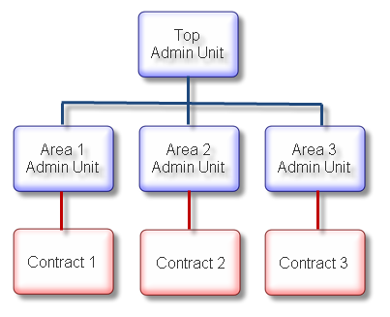
NB. With this security mode in use the Contractor User will be able to view any Work Orders created against the “Dummy” Contract. If the Product Option INCTOPCON is set to “Y” the Contractor User will also be able to View Contracts associated with the top level Admin Unit.

Contractor User Security

The Contractor User security mode is designed for more complex situations for example more than one Contractor works in an Admin Unit or a Contractor Works in several but not all Admin Units at the same level. The Contractor can be associated with Roles and/or individual Users. This allows the creation of a set of Users who have access to any Work Orders etc on any Contracts associated with the Contractor.
Roles and/or Users can be assigned to multiple Contractors allowing, for example, the creation of a Role associated with all Authorities Users and assigned to all Contractors i.e. Users that can view/create Work Order etc for all Contracts.

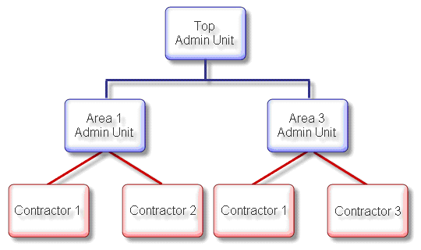

New Product Option CONSECMODE

A new Product Option (CONSECMODE) has been introduced to identify the mode in which Contract Security will operate. This option should be set to one of the following values (enforced by a new domain):-

- “N” Not Enabled (Default)
- “A” Contract Admin Unit Security Enabled
- “U” Contractor User Security Enabled

The Product Option defaults to “N” to allow the system to be used as normal while the data for the required security mode is setup.

Contract Admin Unit Security

To enable Admin Unit Security:-

  - Check that Users and Contracts are assigned to the appropriate Admin Units.

  - Set the Product Option CONSECMODE to “A”.

Contractor User Security

To enable Contractor User Security:-

- Assign appropriate Roles and/or Users to each Contractor using the new tab in mai3881 (Contractors):-

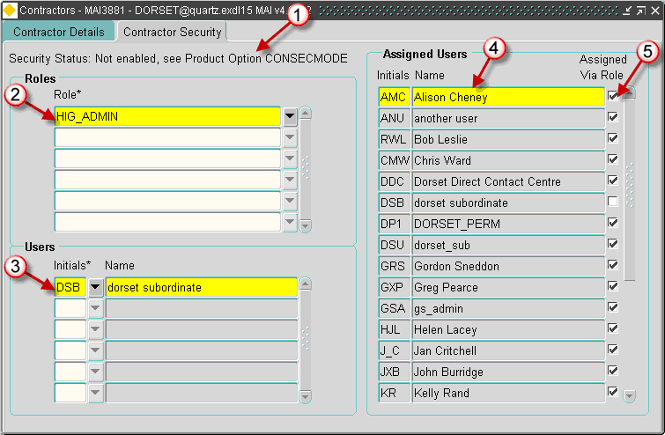

Contractor User Security Status, this lets the user know whether or not Contractor User Security is currently switched on. The text displayed is based on the new Domain “CONTRACTOR_USER_SEC”.

Roles block, this block allows Roles to be assigned to the Contractor, any User with the specified Role(s) will have access to Contracts associated with the Contractor

Users block, this block allows individual Users to be assigned to the Contractor, any User specified in this block will have access to Contracts associated with the Contractor

Assigned Users block, this block displays all User that have access to the Contracts associated with the Contractor either directly or via a Role.

Assigned Via Role checkbox, this checkbox will be ticked if the User has access via a Role.

- Set the Product Option CONSECMODE to “U”.

NB. The original block (now on the Contractor Details tab) has been changed to prevent Users who are not assigned to the Contractor from deleting it.
- Log No. Summary
This chapter summarises all software changes that have been made in this release.

These changes are derived from the following sources :

- Issues raised by Customers via Exor Support
- Issues raised internally by Exor

  - Customer Raised Issues

Support Call No | Issue | Internal Task Id
708493  716502  718142  718866  719607  719958 | Enhancements to the Locator Create Defects form (MAI3807) to allow the user to enter Immediate, Permanent and Temporary repairs for the same defect. See the New Functionality section for further details. | 108043
710478 | The Scheme Type list of values in the Work Orders form (MAI3800) should show the full description. | 107563
710950 | When using the View Asset button in the Defects form (MAI3806), the Assets form (NM0590) is called but the asset details do not appear. | 107294
711109 | When running the Payment Approval form (MAI3856) the latest invoices should appear at the top and it should not be possible to approve previous payments. | 108479
711667 | When entering the Date Repaired in the Work Orders Contractor Interface form (MAI3802), the user should be able to select a date via the standard calendar or mouse right-click functions. | 107316
711943 | When the DUMCONCODE product option contains an invalid value, the Work Orders form (MAI3800) displays an error at startup:  FRM-40735: WHEN-CREATE-RECORD trigger raised unhandled exception ORA-06502 | 107438
714530 | In the Work Orders form (MAI3800) when the item code is changed the costings are not recalculated, unless you tab past the Dim1 field. | 107336
715810 | Additional reference data will be supplied for Financial Years up to 2015. | 107330
716144 | The Save button in the Inspections form (MAI3808) should work in the standard manner. | 107565
716524 | The Work Order Auditing report (MAI3803) should show all the BOQ items for the work order line, not just the first one. | 107362
716538 | The AUTH_OWN product option that allows all users within the system to authorise their own work orders needs to be available as a user option. The customer can then be selective as to who within the organisation is allowed to authorise their own work order. | 107366
716904 | Certain database fields need to be expanded to bring them in line with Core. Maintenance Manager needs to handle 9 digit network element and asset ids as well as 240 character network element descriptions. | 107420
716920 | Changes to allow Cyclic Maintenance Schedules (MAI3860 and MAI3862) to work on a conflated network. | 107698
717036 | When entering multiple defects via the Inspections by Group form (MAI3899) it is too easy to lose data when the [Cancel] button is inadvertently pressed. There should be a prompt to confirm before proceeding. | 107567
717132 | The Summary of Work Volumes by Standard Item report (MAI3934) is only producing the first page of output. | 107418
717190 | When loading Invoice Files (MAI3852) the processing for final invoices does not update budgets correctly. | 107416
717301 | The Print Defect Notices report (MAI3904) is taking too long to run. | 107424
717325 | When processing a WI file using the Invoice Verification form (MAI3854) there should be a warning message displayed when the file cannot be found. | 107569
718180 | The Work Order form (MAI3800) should cater for jobs that need a 2 hour response by allowing entry of a time in the Target Complete. | 107410
718508 | When processing a contractor WI file that contains both temp and perm repairs for the same defect, the two repairs are incorrectly updated with the same completion date. | 107555
718514 | When processing contractor interface files through the Invoice Verification form (MAI3854) the user should be able to process multiple files without exiting the form after each file. | 107378
718851 | When loading invoices the Invoice Verification form (MAI3854) showed details as valid despite an error on an invoice. The Submit/Process button then goes into a loop with the message Financial Debit File Created. | 107571
719057 | When auto loading files via the Contractor Interface, errors were not reported correctly. | 107400
719430 | Enhancements for Contractor Security that makes it possible to set the system up in such a way that individual Contractors can only see details of their own Contracts. See the New Functionality section for further details. | 108042
719790  720445 | When a line was completed in the Work Orders form (MAI3800) the associated defect and repair completion dates were getting set to the system date rather than the actual completion date of the work. | 107394
720289 | Works ordering should be enhanced to allow Discount Group calculations to be carried out accumulatively by discount band. See the New Functionality section for further details. | 108061
720333 | Repair Due Date is calculated incorrectly on Cat 1 defects when loading inspections (MAI2200). | 107669
720373 | When click on lines in the Work Orders form (MAI3800) sometimes get error FRM-40112: Attempted to go_item to none enabled item B2: WOL_DESCR | 107782
720551 | When adding small schemes lines in the Work Orders form (MAI3800) need to be able to enter the location so that a TMA notice can be raised. | 107699
720580 | Inspection Loader (MAI2200) fails with error “Abnormal signal received aborting load” when running with more than 80 activities on an inspection. | 108260
720745 | When trying to amend a defect in the Inspections form (MAI3808) get error FRM-40222: Disabled item `DEF.H_DEF_ST_CHAIN' failed validation | 107757
720881 | Print Work Order (MAI3919) produces too many lines for Sweeping & Cleansing activities, if the XSP is blank on the defect. | 107807
721095 | When load work completion (WC) file through the Contractor Interface get error: ORA-06503: PL/SQL function returned without value. | 107901
721215 | When splitting a section with associated defect data sometimes get inappropriate error: HIG-0436: User is not permitted to operate on the selected network element | 108030
721438 | The Work Orders form (MAI3800) should not allow the user to enter "return" characters in the BOQ Item Description field. These lead to the production of invalid extract files which are rejected by third party systems. | 108210
721875 | When entering BOQ items in the Work Orders form, the details were saved away correctly but could not be edited as they were no longer shown on screen. | 108370
721895 | Print BOQ Work Order Cyclic (MAI3907) is showing incorrect quantities. | 108199
721914 | The Road Section Historical Report (MAI3992) should show the work order Date Confirmed rather than the Date Inspected. | 108201
721915 | The Road Section Historical Report (MAI3992) should show defects in descending order on date inspected. | 108202
722272 | The Treatement Data form (MAI1315) should not jump into enter-query mode when you mouse click outside of the form. | 108324
722836 | In the Inspections form (MAI3808) users should not be able to enter Standard Item codes that have been end dated. | 108488

  - Exor Raised Issues
Internal Task Id | Issue
102950 | When exiting the Work Order form (MAI3800) after having used the gazetteer, it displays an inappropriate message `Do you want to save the changes you have made?'
107633 | Additional metadata is required for Defect Treatments (DEF_TREATS) in line with the RMMS specification. It is not automatically installed but can be added by manually running all or part of the script "maidata7.sql".
107721 | The Budgets form (MAI3660) now allows entry of 3 new costs codes against each budget, for external references to financial systems. See the New Functionality section for further details.
108449 | When running the Work Order form (MAI3800) the following error is displayed after invoking the Contracts or Cyclic Maintenance Schedule screen:  FRM-40815: Variable GLOBAL.QUERY does not exist
108494 | In Query Network / Inventory Data (MAI2140) the Inventory Summary block is showing no items when you first select start / end sections.

